7.1 Types of Economies
Obj:

The Three Key Economic Questions

Economy | Definition | Example
Traditional
Command/Centrally Planned

Karl Marx’s “Communist Manifesto” | - Father of Communism  - believed all politics and history is driven by the struggle ______________________________________________________________  _____________________________________________________________________  _____________________________________________________________________  - Advocated for the ________________________________________________  - believed a societal change can only come ________________________________________________________________  ________________________________________________________________
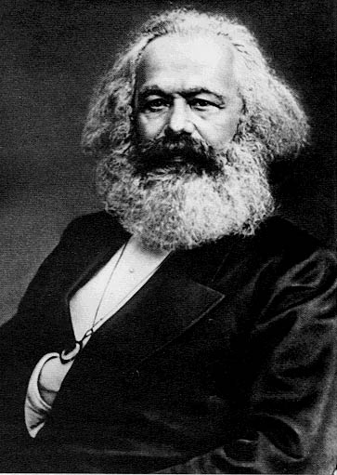
Economy | Definition | Example
Free Market/Capitalist

Adam Smith’s “Wealth of Nations” | - Father of Capitalism  - laissez-faire – ____________________________________________________________  - free enterprise – few _____________________________________________________  - _________________________________________________ regulate the economy; prices lower and quality increases  - “The Invisible Hand” –______________________________________will take care of the economy

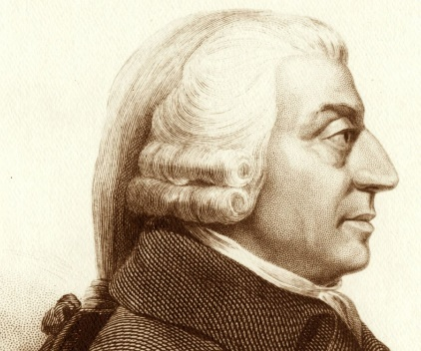

Economy | Definition | Example
Mixed Economy

Socialism | - philosophy that______________________________________________ throughout society and everyone has a role to fulfill within the economy  - can allow for a mix ________________________________________________  - in socialist countries, ____________________________ often owns most major industries and uses wealth for ______________________________________

