Analyzing Data

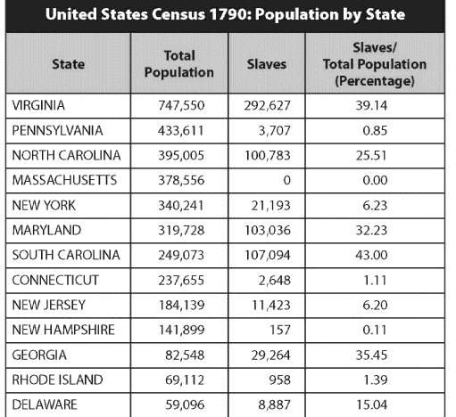

The Founding Fathers considered any state over 250,000 to be a large state.

Determine which state would have been in favor for the various plans of government. Use a check or X to mark each states’ selections.

 | VA Plan | NJ Plan | 3/5 Compromise | Congress Selects President | People Select President
New Hampshire
New York
Massachusetts
Maryland
North Carolina
South Carolina
Pennsylvania
New Jersey
Delaware
Virginia
Georgia
Connecticut
Rhode Island

