Unit 1
Political Cartoon Du Jour

1. Describe what is happening in this cartoon and explain what each element represents.
2. How does this cartoon relate to what we have been discussing in class?

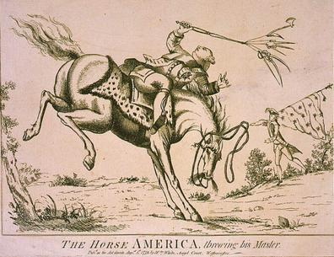

Unit 1
Political Cartoon Du Jour

1. Describe what is happening in this cartoon and explain what each element represents.
2. How does this cartoon relate to what we have been discussing in class?

