Unit 6 Bellwork
Objective 6.1 | Show You Know
Identify the basic principles of economics | 1. Explain the concept of scarcity. How does it impact economics?  2. Where have you seen examples of consumer sovereignty in your own life?  3. What are the four Factors of Production  - -  - -  4. Think of a Peach Pie. Provide one example for each of the Factors of Production that went into making that pie.  - -  - -  5. Explain the difference and connection between a trade-off and opportunity cost.
Objective 6.2 | Show You Know
Identify the circular flow of income | 1. Draw and label the circular flow of economics  2. What exchange occurs in the factor market?  3. What exchange occurs in the product market?  4. What role does the government play in a mixed economy?
Objective 6.3 | Show You Know
Analyze the historical significance and modern impact of labor unions | 1. How did FDR’s New Deal impact American labor?  2. How did Upton Sinclair impact American labor?  3. What is a Right-To-Work Law?  4. What tools can be used by the Labor Union and the Employer when negotiating?
Objective 6.4 | Show You Know
Identify how supply and demand both impact price | 1. Explain the difference between supply & demand  2. What does the Law of Demand sate?  3 What does the Law of Supply sate?  4. Demand Curves are sloped  and Supply Curves are sloped  5. Identify on the graph; Equilibrium price, shortage, surplus, demand curve, supply curve  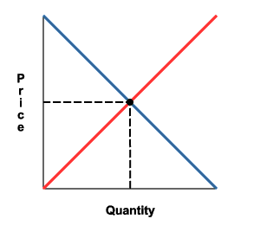  6. Explain the difference between surplus and shortage  7. A change in the quantity demanded due to a price change occurs the demand curve. A change in the quantity supplied due to a price change occurs the supply curve  8. What factors can cause a shift of the Demand curve?  - -  - -  -  9. What factors can cause a shift of the Supply Curve?  - -  - -  - -  10. Provide an example of complementary goods and substitute goods.
Objective 6.5 | Show You Know
Analyze the characteristics of the 3 types of competition | 1. Why is competition important?  2. Provide an example of Monopolistic Competition. Explain why it is so.  3. Provide an example of Oligopolistic Competition. Explain why it is so.  4. Provide an example of Perfect/Pure Competition. Explain why it is so.

